Drupal Report

[Drupal](https://www.drupal.org/) is quickly becoming the most used content management system for Fortune 500 companies. After delving into its administrator’s panel and downloadable extensions, you can see why this is the case. Out of the box, it is highly scalable with a mobile-first design, content is easy to author, content architecture is flexible, and you have the ability to manage multiple sites on a single platform.

**DRUPAL VS OTHER CMS**

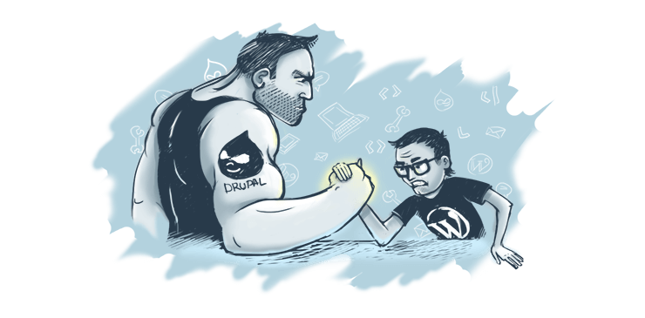

**SECURITY**

Unlike other CMS like [WordPress](https://wordpress.org/) or [Joomla](https://www.joomla.org/), Drupal is much more than a blogging application. Security is a major difference with Drupal being more “enterprise” level than other CMS, which is why sites like Whitehouse.gov prefer it. Hackers often target the two most popular CMS, WordPress and Joomla. While, these two do actively respond to security threats, Drupal offers more management by allowing you to host your site through application like Acquia or Pantheon, which monitor threats.

**EASE OF USE**

Let’s be honest, Drupal isn’t the most user-friendly CMS out there. It’s a powerhouse for a reason. It’s not designed for someone who just wants a simple, no-nonsense site. It is made for those who desire AWESOMENESS! With this, there comes a learning curve. The installation of Drupal is a little longer than WordPress or Joomla but I have provided step-by-step instruction [here](https://hraemoore.wordpress.com/2017/09/07/installing-and-using-drupal/). The interface takes some practice to fully grasp but the payoff is worth it when you see the full functionality that you have access to.

**FUNCTIONALITY**

Drupal has great standard features, like easy content authoring, reliable performance, and excellent security. Articles and basic pages are simple to add. Menus are easy to update. You can apply a new theme to your page by merely copying from the [Drupal.org downloads page](https://www.drupal.org/project/project_module) and pasting the link into the Appearance tab on your site. This is just the basics of what you can do with your site.

Modules allow you to explore how your can further extend the capabilities of your page. From embedding a video into an article to adding a shopping cart to your page, modules give you the ability to expand the functionality of Drupal. Because of Drupal’s open-source nature, most modules are actively maintained by multiple developers, giving you the confidence that your extensions will work correctly.

Similar to other CMS, Drupal allows for different types of content containers. When you initially start with your new Drupal project, you will only have two available content types, article or basic page. These are pretty self-explanatory. Articles are like blog post where you can add tags and you have the option to allow for comments. Basic pages are where you would create entire pages like an “About Me” page that doesn’t allow tags or comments. In addition, Drupal offers views, which allow administrators to create, manage, and display lists of content, for example, a page containing all of the articles. These views can be used as navigation aids such as menu items.

This in-depth info graphic will give you a closer look at the comparison and pros and cons of Drupal, WordPress, and Joomla.



**CONCLUSION**

While Drupal has its similarities to other content management systems like WordPress or Joomla, you can definitely see why it is the most used CMS for large enterprises. With it’s speed, strength, and security it is clear why it is being utilized by more and more professional developers. Drupal may not be the right choice for everyone but if you are looking for a powerhouse CMS, it might just be the one for you!

**********COMMENTS************

I wish we were spending more time on Drupal. I’d like to explore more about this CMS since many companies are using it now. I really like how much you can expand your site with Drupal.

Link to live blog post:

<https://hraemoore.wordpress.com/2017/09/12/drupal-report/>